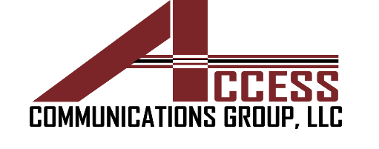 | ACCESS COMMUNICATIONS GROUP, LLC  2017 Texas Ave.  El Paso, TX 79903  Phone: (915) 845-0007  Fax: (915) 565-1717  access@acglp.com www.acglp.com
Job Title: Construction Project Manager
Division/ Departments: Construction
Work Location: 2017 Texas Ave, El Paso TX 79901
Job Type: Full-Time (40 hours/week) | Pay Rate: Hourly ☐ Salary ☒
Reports To: David Portillo ( Project Manager) | Supervisory Capacity: Yes ☒ No ☒
Job description
We are seeking a hardworking and reliable Construction Project ManagerThe ideal candidate will have a strong background in construction management, excellent leadership skills, and a proven track record of successfully managing complex construction projects and building client relationships

Key Responsibilities
- Oversee the planning, execution, and completion of construction projects.
- Ensure projects are completed on time, within budget, and to the highest quality standards.
- Coordinate with project managers, site supervisors, and other team members to ensure efficient project delivery.
- Monitor project progress, identify potential issues, and implement corrective actions as needed.
• Prepare accurate and detailed cost estimates for construction projects.
• Analyze project specifications, drawings, and other documentation to determine project requirements.
• Collaborate with subcontractors and suppliers to obtain competitive pricing.
• Review and approve final estimates before submission to clients.
• Provide technical guidance and support to the engineering team.
• Ensure all engineering work complies with industry standards and regulations.
• Review and approve engineering designs, plans, and specifications.
• Coordinate with architects, engineers, and other stakeholders to resolve technical issues.

Vocational Training Provided By
Management Team

Company Core Values are required to be followed and maintained by every employee.
Accountability. Takes ownership of their deliverables; admits mistakes. First being true to ourselves and then to the rest.

Character as a company Is the distinctive mark/trait that sets us apart from all the others. It is our distinguishing quality feature both, for ourselves and those we interact with.

Integrity. Being honest and showing a consistent strong moral and ethical principles and values.

Safety. #1 value to us. Condition of being protected from or unlikely to cause danger, risk, or injury.

Teamwork. Work together with the team to achieve a common goal or to complete a task in the most effective and efficient way.

Trustworthy. We provide constructive feedback despite personal differences in order to achieve the desired results. Solution versus positional mindsets that utilize shared values as an integral culture of synergy.

Requirements
- Construction proficiency is required
- Follow Access Employee Handbook and Safety Handbook.
- Strong leadership and team management skills.
- Excellent communication and interpersonal skills.
- Proficiency in construction management software and tools.
- Ability to work under pressure and meet tight deadlines.
- Strong analytical and problem-solving abilities.
- Ability to lift up to 25 lbs.
- Dexterity – Full range of motion of hands and fingers is necessary
- Ability to work at a computer for extended period of time

